What’s New in Web-O-Rama Professional 8?

September 11, 2001
Web-O-Rama Professional 8 utilizes an all-new editing window interface that features as-you-type syntax coloring, automatic uppercasing or lowercasing of HTML tags, line numbers, unlimited undo/redo, and much, much more.

Main Editing Window

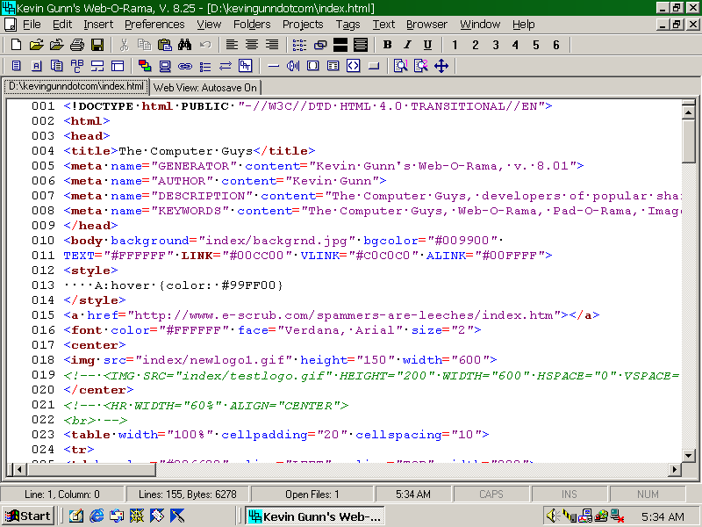
Web-O-Rama Professional 8 also includes a Web View tab that allows you to instantly preview your code in an Internet Explorer–style browser window.

Web View Tab

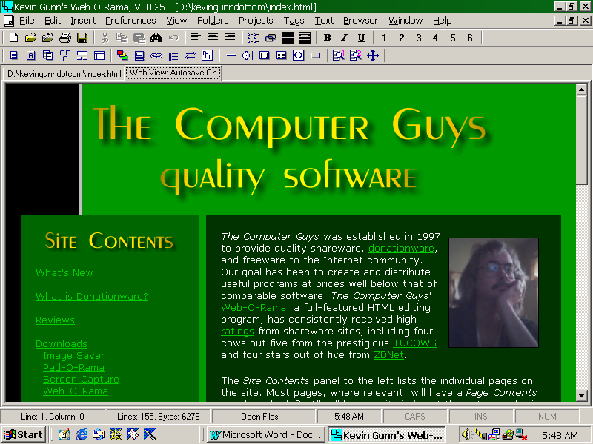
Web-O-Rama Professional 8 is available on CD only. All CDs will contain Web-O-Rama Professional 8 as well as the latest version of Web-O-Rama Pro Classic. Please use the order form below to get a copy today!

Web-O-Rama Order Form
Prices good through 1 January 2002. Version on CD will be latest release version.

PRODUCT | PRICE | QUANTITY | AMOUNT
Web-O-Rama Professional and Web-O-Rama Pro Classic on CD  Please visit The Computer Guys’ Web site at www.kevingunn.com for additional details about Web-O-Rama Professional 8. | $35.00
Web-O-Rama Pro Classic on CD | $29.00
Web-O-Rama Pro Classic .exe-only e-mailed to you  The .exe-only version requires prior installation of the latest version of Web-O-Rama Standard, and Internet Explorer 5 or higher. | $21.00
Special upgrade price for people who have purchased an earlier version of Web-O-Rama Professional. This is for the cost of the CD, mailer, and postage. There is no additional charge. | $ 6.00
Additional postage for international orders | $ 2.00
TOTAL AMOUNT (prices above include domestic postage, handling, etc.)

PLEASE PRINT LEGIBLY AND PROVIDE AN E-MAIL ADDRESS
Name: _____________________________________________________________________________
Address: ___________________________________________________________________________
___________________________________________________________________________________
City: _________________________________ State: ________________________ Zip: ____________
E-mail Address (very important): ______________________________________________________
Do you need the special Windows ME version? Yes _________________ No ________________

Mail order form to Kevin Gunn, P.O. Box 442155, Lawrence KS 66044-8933
To speed delivery, please e-mail me at compguys@eudoramail.com notifying me you have placed an order. Allow 2 to 4 weeks for processing and delivery. E-mail me at compguys@eudoramail.com if you become concerned about any delay. If you cannot reach me at compguys@eudoramail.com, visit www.kevingunn.com for the latest contact information.

